2019 BALSA WOOD BRIDGE COMPETITION

Saturday, March 2th, 2019
WS SPEED HALL ROOM 013
JB SPEED SCHOOL OFENGINEERING

COMPETITION CONTACT INFORMATION

Marty Brown vp@speedcouncil.org
Engineering Exposition Coordinator
Executive Vice President, Speed School Student Council

Katie Kalbfleisch kakalb01@louisville.edu
Vice President of Activities, ASCE/SAME Student Chapter
Civil & Environmental Engineering Department, University of Louisville

Mark McGinley, Ph. D. m.mcginley@louisville.edu
Professor & Endowed Chair for Infrastructure Research
Civil & Environmental Engineering Department, University of Louisville

COMPETITION DEADLINES

Check-in on competition day begins at 8:30am with final check-in at 10:00am in WS Speed Hall 013. Bridges will be weighed in and judged for best aesthetics and construction methods at that time. Please review the form (shown with example members) before completing with your team information. Make sure the primary e-mail address given is checked daily for any notices or modifications sent out by the Competition Committee. Also note that bridges that do not meet the construction requirements described in the following section will not be eligible for awards and may not be tested. Testing will begin approximately 9:00 am.

AWARD CATEGORIES

! Most Efficient Bridge (1st / 2nd / 3rd place awards given)
! Best Construction / Visually Appealing (1st / 2nd / 3rd place awards given)

We plan two divisions:
- Elementary/Middle
- High School

CONSTRUCTION RESTRICTIONS

1. Materials used in the construction of the bridge shall consist only of
commercially available balsa wood stock and glue. Any appropriate glue may be used, but no metal or plastic fastenings are allowed.

2. The bridge shall be constructed balsa wood sticks that are no larger than 3/8 in. x 3/8 in. It is permissible to laminate two or more elements, each separately meeting the size requirement, to construct members exceeding these dimensions.

3. Gusset plates can be used but cannot exceed (may be samller) 1 in. x 1 in. x ½ in. in dimension and must also be balsa wood. Gusset plates can be used only at connections

4. The bridge must allow a 2” cube to pass along the “roadway” without touching the structure. A road bed is not necessarily required, you can just have beams that will support the cube. The bridge must be at least 17 in., but no more than 18 in. long. The bridge cannot be more than 5.5 in. wide, in order to properly fit in the testing apparatus (see Figure 1). The bridge cannot be more than 6 in. height above the supports, nor more than 4 in. below the supports.

5. The bridge shall be "free standing".

6. No fastening mechanisms except mechanical interlock (wood joinery) of the balsa pieces may be used. Glue shall only be applied at the joints. No coating of members for reinforcement (except if you laminate members and the glue is allowed only at the member interfaces. Gusset plates may be used as long as they do not exceed the size in Rule 3.

7. The bridge design shall allow the standard test frame and steel rods shown (Figure 2) to be placed around the bridge. The load support rods will be placed as close to the third points of the bridge span as possible (approx. 6 in. apart and about 5.5 in. from the ends), and will extend beyond the bridge sides. Please provide loading points for the 3/8 in. diameter rods and a clear space in the bridge so that they can extend through to both sides of the bridge.

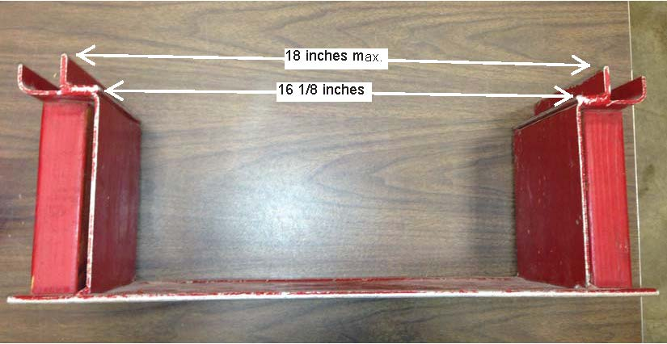
16-1/16” inches
Figure 1 Test Stand

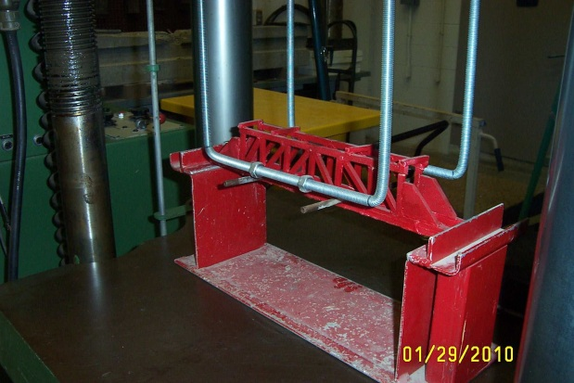
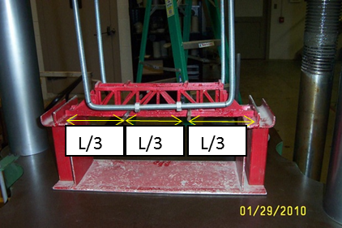
Loading Pins

For Length – 17 in Loading points 5.5”, 6”, 5.5”

Figure 2. Typical bridge testing setup

BRIDGE TESTING

- The bridge will be inspected and weighed, then impounded until tested.

2. The bridge pedestals shall be placed on level surfaces separated by approximately 16 in. These surfaces shall be level with respect to each other.

3. The standard test frame will be placed around the bridge with the rods located near the span third points. Depending on the bridge design, the load will be applied to either the upper or lower chords of the bridge. The judges reserve the right to modify loading conditions. Figure 2 illustrates a typical bridge testing setup. Notice the locations of the load support rods with the loading frame resting on top of them.

4. The load will be applied by a universal testing machine at a slow, steady rate, until either an audible cracking sound or visual evidence indicates the failure of some structural member or glue joint of the bridge, or until a suitable reference point on the roadway at the center of the span has been lowered by more than 1”. A competitor may not participate in the setup or loading of his/her bridge.

5. The total mass of the test frame and applied load shall be divided by the structure weight to determine the score. A category will also exist for the best bridge with the best overall construction.

COMPETITION COMMITTEE RELEASE STATEMENT

Note: All rulings made by the judging committee are final.

.

