“Rube Goldberg” Competition
2019 Rules and Regulations

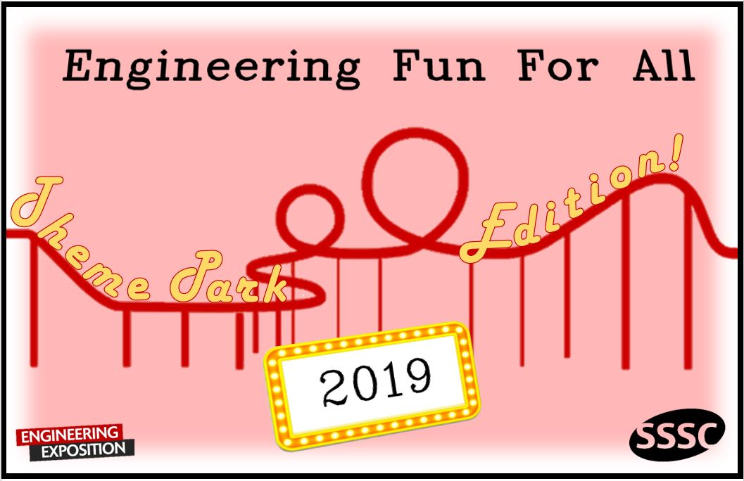

March 2nd, 2019
J.B. Speed School of Engineering
Room: TBD

Elementary School Division: K - 5th
Middle School Division: 6th - 8th
High School Division: 9th - 12th

Contact Information:
Marty Brown
Engineering Exposition Coordinator
Executive Vice President of SSSC
vp@speedcouncil.org
TO PARTICIPATE IN THE RUBE GOLDBERG MACHINE CONTEST:
- Start a team (or participate individually)
- Register for the Rube Goldberg competition beginning on December10th , 2018
  - Go to engineering-expo.com
  - Click on ‘Register’
  - Complete the form to reserve a spot for E-Expo
- Design and build a machine
  - 201 task: Make a “Farris Wheel” turn
    - Note: Any sort of wheel will work i.e. pinwheel, toy bike wheel etc.
- Compete!
  - E-Expo will be will held on March 2, 2019 at the J.B. Speed School of Engineering
  - Teams/individuals will be notified of their assigned judging time closer to the event

COMPETITION RULES

Specification | Value
Objective | Spin your “Farris Wheel” 1 full revolution, although more is allowed.
Group size | 1-5 students (in same age group)
Minimum number of steps | 5
Maximum machine volume | 3’ x 3’ x 3’
Number of runs for judging | Up to 3 (2 required)
Maximum time for judging (students must be present during judging) | 10 min

JUDGING CRITERIA
All judging will be completed during the competition on March 2nd, 2019. Presentation of awards will be given after the keynote speech to top students in each division. Students must be present to win their award.
Rube Goldberg Judging Form

Group/Individual Student Name:

Group: Elementary Middle High

Judge Use Only

Successfulness
1 5 10 _____

Creativity
1 2 3 4 5 6 7 8 9 10 _____

Difficulty
1 2 3 4 5 6 7 8 9 10 _____

Appearance
1 2 3 4 5 6 7 8 9 10 _____

Presentation/Discussion
1 2 3 4 5 6 7 8 9 10 _____

Bonus (Judge's Discretion) _____

Total _____

